Spring Boot = Spring + Boot
Spring → Provides features
Boot → Makes Spring easy & fast
Spring Boot = Spring Framework + Auto Configuration + Embedded Server

Spring Boot is a Java-based framework designed to simplify and make applications production-ready, particularly for REST APIs and microservices.

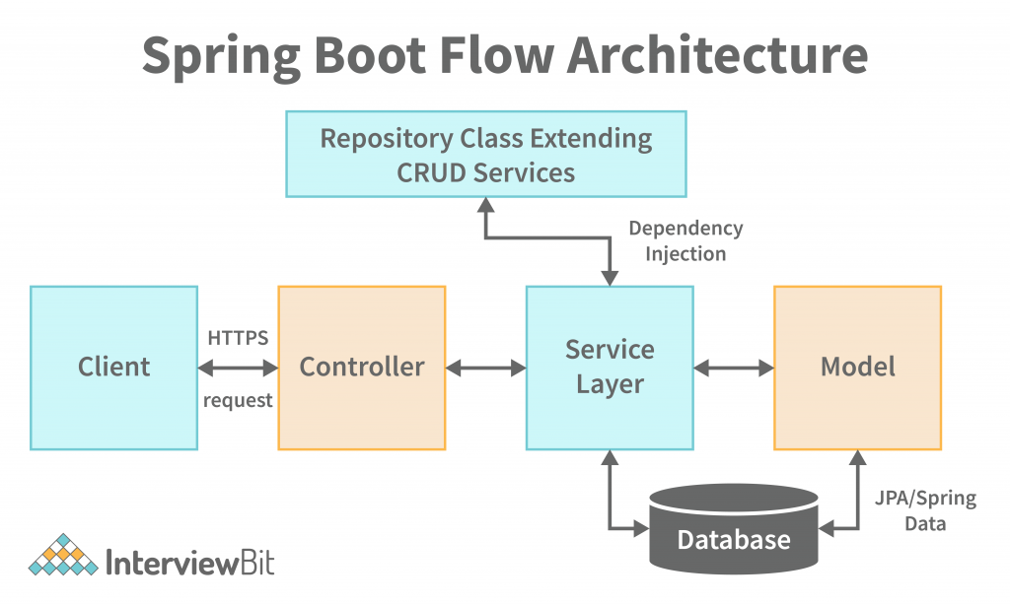

Spring Boot uses a layered architecture, where each layer has a clear responsibility.

Presentation Layer (Controller Layer)

- Handles HTTP requests and responses
- Communicates with the service layer
- Uses annotations:
  - @RestController……@getMapping and @PostMapping
  - @Controller
- Example: REST APIs, web endpoints
Service Layer (Business Logic)
- Contains business rules and logic
- Acts as a bridge between controller and repository
- Uses:
  - @Service

Persistence Layer (Repository / DAO)
- Handles database operations
- Uses:
  - @Repository
  - Spring Data JPA….this is dependency
- Performs CRUD operations

Database Layer
- Stores application data
- Examples:
  - MySQL
  - PostgreSQL
  - Oracle

Supporting Components
- Spring IoC Container
  - Manages object creation and dependency injection
- Auto Configuration
  - Automatically configures beans based on classpath
- Embedded Server
  - Tomcat (no external server required)

Features of Spring Boot
1. Auto Configuration
- Automatically configures application based on dependencies
- Reduces manual configuration

2. Embedded Server
- Built-in servers like Tomcat
- No need to deploy WAR files
- Application runs as a standalone JAR

3. Starter Dependencies
- Predefined dependency bundles
- Examples:
  - spring-boot-starter-web
  - spring-boot-starter-data-jpa
- Avoids version conflicts

🔹 4. No XML Configuration
- Uses annotations and properties
- Cleaner and easier to maintain

🔹 5. Production Ready Features
- Spring Boot Actuator:
  - Health check
  - Metrics
  - Monitoring

🔹 6. Faster Development
- Minimal setup
- Rapid application development
- Ideal for microservices

Spring vs Spring Boot

Feature | Spring Framework | Spring Boot
Configuration | Manual configuration (XML / Java Config) | Auto-configuration
Ease of Use | Complex for beginners | Easy and beginner-friendly
Starter Dependencies | Not available | Available (spring-boot-starter-*)
Server Setup | External server required | Embedded server (Tomcat/Jetty)
Deployment | WAR file deployment | Standalone JAR
Development Speed | Slower | Faster

Creation of a Spring Starter Project, including project structure:

Step1)
Open https://start.spring.io
Fill the details:
- Project: Maven
- Language: Java
- Spring Boot: (default selected)
- Group: com.example
- Artifact: hellogopi
- Name: hellogopi
- Packaging: Jar
- Java: 17 (or 21)
Right side Add Dependencies:
- Add Spring Web
Click Generate
A ZIP file will be downloaded

Step2)
- Open STS
- Go to File → Import
- Select:
- Maven → Existing Maven Projects
- Click Next
- Browse and select the extracted project folder
- Click Finish
Project will appear in Project Explorer

Step3)
Now expand your Project
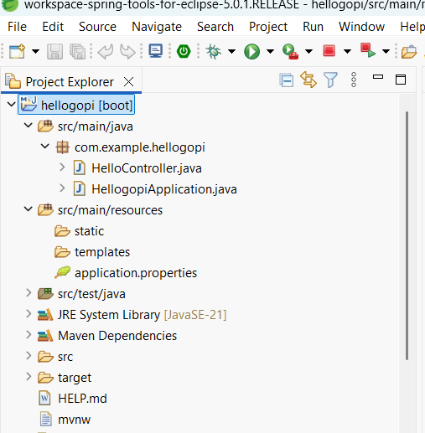

No need to create a class under.
src/main/java
└── com.example.hellogopi

Right click on com.example.hellogopi ->New->Class->HelloController(is the name of the class)

Now inside the class(HelloController) take this code:
package com.example.hellogopi;

import org.springframework.web.bind.annotation.GetMapping;
import org.springframework.web.bind.annotation.RestController;

@RestController

public class HelloController {

@GetMapping("/hello")
public String hello() {
return "Hello Gopi";
}

}

Next step)

Now Right click on your Spring project->Click on Maven->update Project

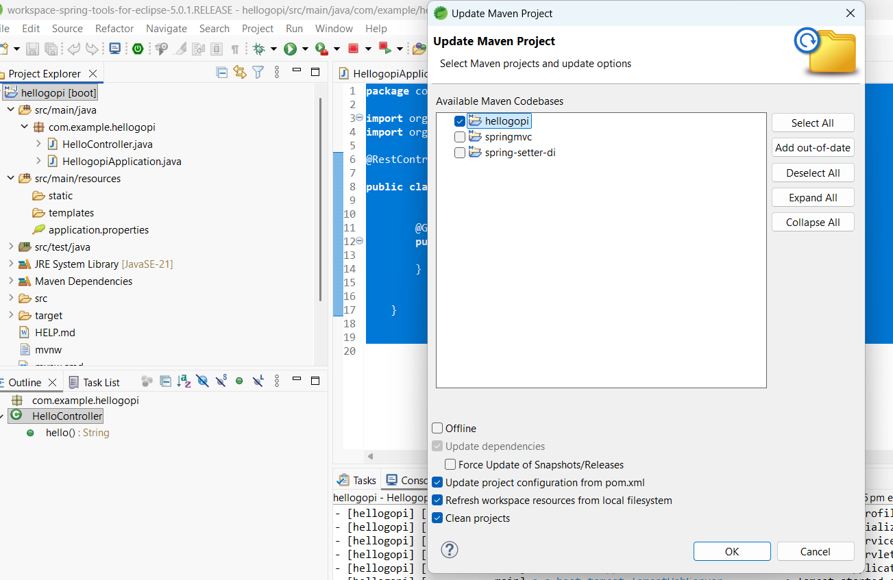

Force update snaps/releses.

Next step)
Right click on project
Select Run As → Spring Boot App
In console you should see:
Tomcat started on port(s): 8080
Started HellogopiApplication

ALERT: How to resolve this Error: Port 8080 was already in use
Now Goto src/main/resources
Click on Application.properties:
Add this line:
spring.application.name=hellogopi //existing line
server.port=8081 //added line by us

Restart the application
- Right click project
- Run As → Spring Boot App
Test in browser
http://localhost:8081/hello

Last step:
Test in Browser
Open browser and type:
http://localhost:8080/hello

Added Another mapping;

package com.example.hellogopi;

import org.springframework.web.bind.annotation.GetMapping;
import org.springframework.web.bind.annotation.RestController;

@RestController

public class HelloController {

@GetMapping("/hello")
public String hello() {
return "Hello Gopi";
}

@GetMapping("/sandeep")
public String helloSandeep() {
return "Hello Sandeep";
}

}

Before check the output must Stop server and start again

http://localhost:8081/sandeep
Check the output now:

Simple Login Page using Templates
Steps needed:
- Add Thymeleaf dependency
- Create a Controller for pages (@Controller)
- Create HTML templates
- Run & test in browser
Step1)
Open pom.xml and add this dependency inside <dependencies>: after line number 36:

<dependency>
<groupId>org.springframework.boot</groupId>
<artifactId>spring-boot-starter-thymeleaf</artifactId>
</dependency>

Step2)
Create a new Controller
src/main/java
└── com.example.hellogopi
Under this
Create New → Class → Name: LoginController

LoginController.java:
package com.example.hellogopi;

import org.springframework.stereotype.Controller;
import org.springframework.web.bind.annotation.GetMapping;
import org.springframework.web.bind.annotation.PostMapping;
import org.springframework.web.bind.annotation.RequestParam;

@Controller
public class LoginController {

@GetMapping("/login")
public String loginPage() {
return "login";
}
@PostMapping("/login")
public String loginSubmit(@RequestParam String username,
@RequestParam String password) {

if(username.equals("admin") && password.equals("admin")) {
return "success";
} else {
return "login";
}
}
}

Now Create Login HTML Page:
src/main/resources/templates/login.html

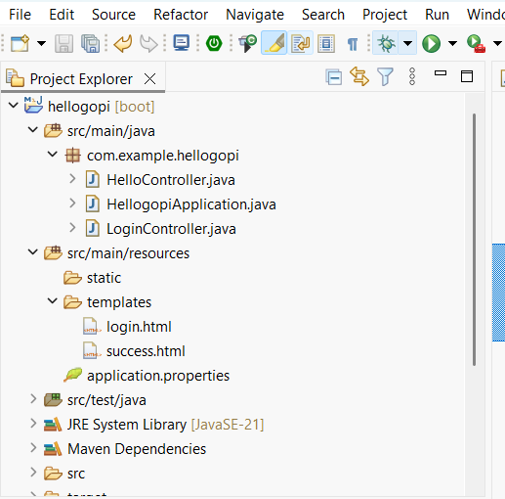

Login.html code:

<!DOCTYPE html>
<html>
<head>
<title>Login Page</title>
</head>
<body>

<h2>Login</h2>

<form action="/login" method="post">
<label>Username:</label>
<input type="text" name="username" required /><br><br>

<label>Password:</label>
<input type="password" name="password" required /><br><br>

<button type="submit">Login</button>
</form>

</body>
</html>

Create Success Page
Path:
src/main/resources/templates/success.html
success.html code:
<!DOCTYPE html>
<html>
<head>
<title>Success</title>
</head>
<body>

<h2>Login Successful </h2>
<p>Welcome to Spring Boot Templates</p>

</body>
</html>
=================================================================
Run the Application
- Stop the server (very important)…..Update the Project
- Right click project
Run As → Spring Boot App
Console should show:
Tomcat started on port(s): 8081
Started HellogopiApplication
------------------------------------------------------------------------------
Test in Browser
Open:
http://localhost:8081/login
Task1) Create a Registration Page
Task2) Student Grade Calculator using Spring Boot (Without Database)
Develop a Spring Boot application that provides a REST API to calculate a student’s grade based on the marks obtained.
The application should expose a GET endpoint that accepts the student’s marks as an input parameter and returns the marks, grade, and result as a JSON response.
Use the following grading criteria:
- If marks are greater than or equal to 90, assign Grade A and Result Pass
- If marks are between 75 and 89, assign Grade B and Result Pass
- If marks are between 50 and 74, assign Grade C and Result Pass
- If marks are less than 50, assign Grade F and Result Fail
Constraints:
- Do not use any database.
- Use Spring Boot REST annotations.
- The API should return data in JSON format.
- Validate that marks are between 0 and 100.
Example:
If the input is marks = 82, the output should contain marks as 82, grade as B, and result as Pass.
What is MVC Architecture?
MVC stands for:
- M – Model
- V – View
- C – Controller
In Spring Boot, MVC is used to separate responsibilities so code becomes:
easy to understand
easy to maintain
easy to test
Flow of MVC:
User → Controller → Service → Model → View → User
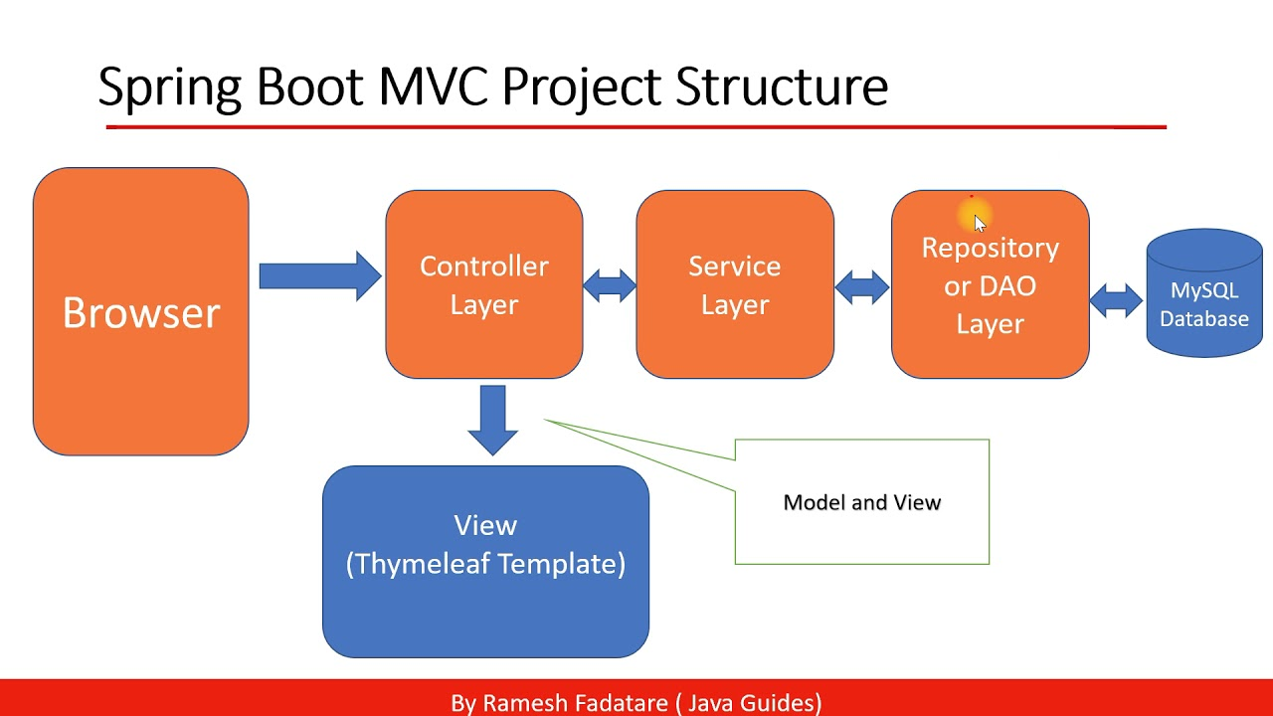

What is Controller?
- Entry point of the application
- Receives HTTP requests
- Decides what logic to call
- Returns response / view
Spring Boot Annotation
@RestController OR @Controller
Example
@RestController
public class HelloController {

@GetMapping("/hello")
public String sayHello() {
return "Hello Spring Boot MVC";
}
}

From controller it goto the Services layer

Model (M)
What is Model?
- Represents data
- Plain Java class (POJO)
- Holds variables + getters/setters

Example
public class Student {
private int id;
private String name;

// getters and setters
}

